iOS mOcean SDK

Developer Guide

For iOS SDK Version 2.10

Table of Contents

Table of Contents 2

What’s new in 2.10 3

How to move from previous version to 2.10 4

System Requirements 4

Feature list 5

Installing the Ad SDK 6

Add the Latest version of SDK library project to your app 6

Add Frameworks and libraries to your project 7

Set Target Dependencies 8

Install Documentation 8

Use case MASTAdView 9

Simple ad integration 10

Interstitial ad integration 13

Customize MASTAdView 15

Customize view appearance. 15

Customize content. 16

Customize Interstitial ad 17

Customize view appearance. 17

Customize content. 17

Customize Ad Updates 18

Duplicate symbol compile error 19

Ads are not displayed the way you want. 19

MASTAdView Class Reference 20

Overview 20

Tasks 20

Properties 22

Instance Methods 34

MASTAdViewDelegate Protocol Reference 37

Overview 37

Tasks 37

Instance Methods 37

# What’s new in 2.10

* The prefix ‘MAST’ was added for all classes
* The class AdViewInterstitial was deprecated
* Add stop the world method
* There was set internalOpenMode property default value to FALSE
* The property showCloseButtonTime was added to MASTAdView
* The property autoCloseInterstitialTime was added to MASTAdView
* There was set isAdChangeAnimated  property default value to FALSE
* The property autoCollapse was added to MASTAdView
* The property showPreviousAdOnError was added to MASTAdView
* The adCallTimeOut was added to MASTAdView
* Ignore content, if server returned response code != 200
* The animation was turned off on expand/resize/close ORMMA methods
* The sample applications were updated

# How to move from previous version to 2.10

1. You should change all ads of the class from “AdView.h”, “AdViewInterstitial.h” into “MASTAdview.h”
2. You may use “MASTAdViewInterstitial.h” instead of “AdViewInterstitial.h” in the current version, please pay attention that in the next versions the current class will be removed, so we recommend to use “MASTAdview.h”.
3. For the usage of the interstitial banner through MASTAdview, it’s necessary to setup showCloseButtonTime or autoCloseInterstitialTime in the meaning of more than -1.

The properties’ description can be found in API.

SDK Dependecies

* Reachability version 2.2
* QSUtilities
* UIAlertView-Blocks

If you are planning to use these libraries in the project, you may use them from Source/Libs folder. If you want to update the libraries to latest versions, it’s necessary to replace the old one in the ‘Source/Libs’ folder, pay attention, that in this case we don’t guarantee the SDK functionality working.

# System Requirements

* Intel based Mac
* iOS 4.0 or higher
* XCode 4.2 or higher

# Feature list

* **Rich media**

SDK supports ORMMA level 1.1 and MRAID level 1.0. [See more](http://code.google.com/p/ormma/).

* **HTML/ JS ads**

SDK supports displaying web ads using UIWebView component.

* **Location auto detect**

SDK could automatically detect user location

* **User-Agent auto detect**

SDK automatically detects device User-Agent

* **Internal browser**

SDK contains built-in browser for displaying ads in application

* **Ad visibility tracking**

SDK automatically detects ads visibility for controlling updates

* **Logging**

SDK supports logging.

# Installing the Ad SDK

## Add the Latest version of SDK library project to your app

Add the MASTAdView.h, MASTAdDelegate.h header files from Public folder into the SDK sources and library project.

Select Classes, then right-click and select Add Files to “Project Name”...

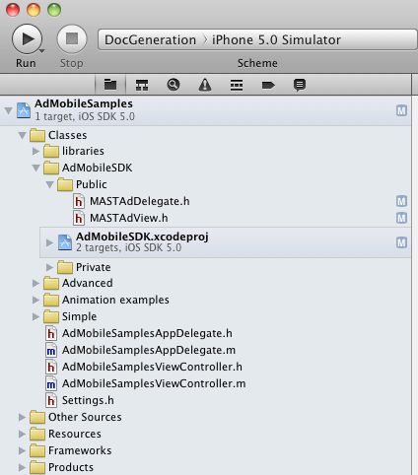

## 

## Add Frameworks and libraries to your project

Add the following frameworks and libraries to you project:

* libAdMobileSDK**.a**
* CoreGraphics
* CoreTelphony
* CoreMotion
* EventKit
* MediaPlayer
* MessageUI
* QuartzCore
* SystemConfiguration

Select Project> Target>Build Phases, then add frameworks to the “Link Binary With Libraries” section

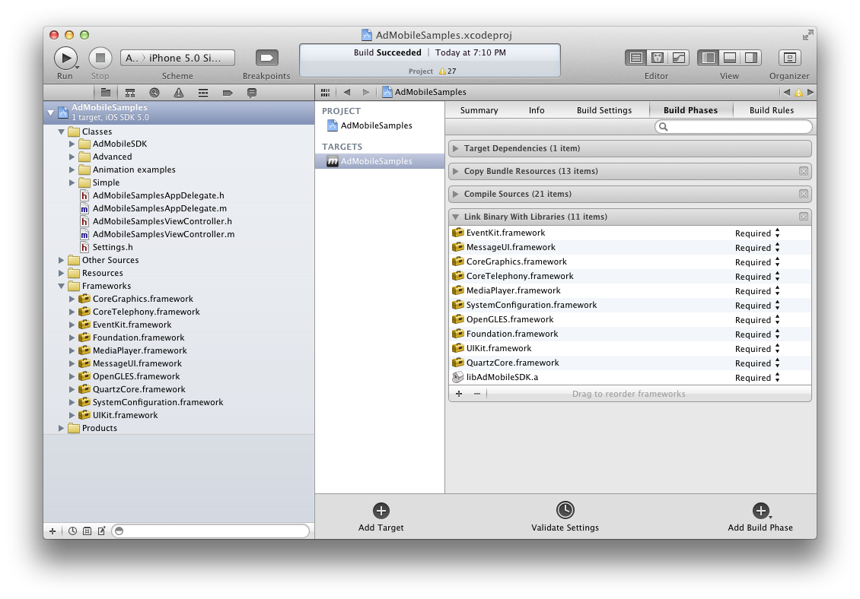

## Set Target Dependencies

Select Project, Target, Build Phases, then add AdMobileSDK target to the “Target Dependencies” section.

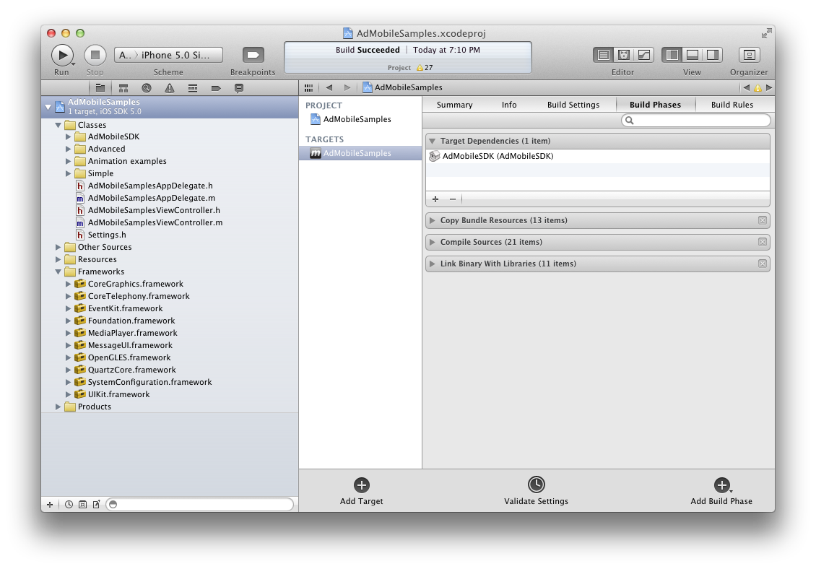

## Install Documentation

SDK includes XCode documentation in the“Documentation\Reference” folder.

Run installdocset.sh script in Terminal.app to copy documentation to XCode or you can use web based version of documentation in html folder

# Use case MASTAdView

1. A simple banner that is used for the embedding of the existing form and occupies a small area in it. You can view how to use this banner in the application here.
2. Interstitial is used for the full screen banner display. It’s displayed only once and after closing it becomes inactive.
   1. Full screen banner is shown as a pop up on top of the main screen of the window and blocks all user’s actions with the application.
   2. Full screen banner is shown as a pop up on top of the main screen of the window and doesn’t blocks all user’s actions with the application. As an example, user can switch tabs.
   3. If several displays are switched on, banner will be displayed on the main screen only

You can view how to use the Interstitial banner in the application here.

# Simple ad integration

To add MASTAdView into your application just import MASTAdView.h

#import "MASTAdView.h"

And put initialize code in (void)viewDidLoad method

- (void)viewDidLoad

{

MASTAdView *_adView = [[MASTAdView alloc] initWithFrame:CGRectMake(0, 0, self.view.frame.size.width, 50.0) site:19829 zone:88269];

[self.view addSubview:_adView];

[_adView release];

[super viewDidLoad];

}

See Also:

* For more code samples examine AdMobileSamples application

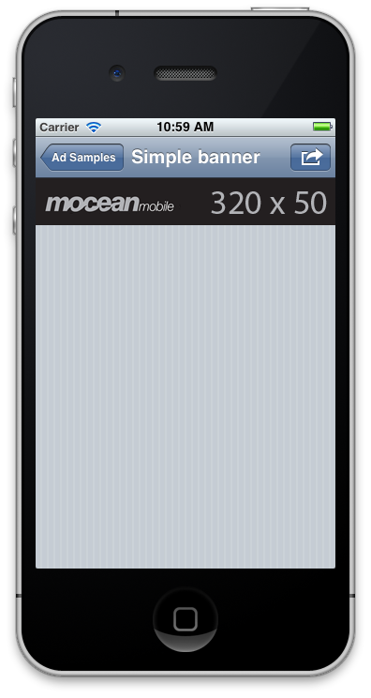

If there are several ads of different sizes in the same Zone, this can be useful for the targeting of the different devices, such as: iPhone3G, iPhone4, iPad, but it’s necessary to tell the server what size of the banner required. To setup the ad size, please use minSize and maxSize parameters. If the parameter maxSize SDK isn’t initialized, SDK uses the sizes of UI control.

MASTAdView *_adView = [[MASTAdView alloc] initWithFrame:CGRectMake(0, 0, self.view.frame.size.width, 100.0) site:19829 zone:88269];

On this line of the iPhone4 devise, iPad banners will be cut, as the maxSize.width is equal to self.view.frame.size.width. SDK care about DPI, and sends x2 values for iPhone4, iPhone4s.

To prevent the appearance of iPhone3G banner on Retina display, it’s necessary to set the minSize.

- (void)viewDidLoad

{

MASTAdView *_adView = [[MASTAdView alloc] initWithFrame:CGRectMake(0, 0, self.view.frame.size.width, 100.0) site:19829 zone:88269];

CGFloat scale = [UIScreen mainScreen].scale;

adView.minSize = CGSizeMake(self.view.frame.size.width*scale, 50*scale);

[self.view addSubview:_adView];

[_adView release];

[super viewDidLoad];

}

During the rotation of the display, iOS is turning the coordinate system, and in case if the maxSize isn’t overwritten in application code, the SDK will be able to update the value maxSize value on display rotation. minSize is set by the user, not by the SDK, that’s why if they are initialized, the user must replace them during the rotation, and care about DPI.

If the minSize > maxSize, the parameters will be ignored by ad server, and in the log there will be a warning message. Below you will see the sample how to update ad on rotation.

- (void)didRotateFromInterfaceOrientation:(UIInterfaceOrientation)fromInterfaceOrientation

{

CGFloat scale = [UIScreen mainScreen].scale;

adView.minSize = CGSizeMake(self.view.frame.size.width*scale, 50*scale);

[_adView update];

}

# Interstitial ad integration

To add interstitial ad into your application just import MASTAdView.h

#import " MASTAdView.h"

And put initialize code in (void)viewDidLoad method

- (void)viewDidLoad

{

[super viewDidLoad];

MASTAdView *_adView = [[MASTAdView alloc] initWithFrame:CGRectMake(0.0, 0.0, self.view.frame.size.width, self.view.frame.size.height) site:19829 zone:88269];

_adView.minSize = CGSizeMake(self.view.frame.size.width, self.view.frame.size.height);

_adView.showCloseButtonTime = 5;

_adView.autocloseInterstitialTime = 15;

[self.navigationController.view addSubview:adView];

[adView release];

}

You have to put up one of the properties showCloseButtonTime or autocloseInterstitialTime is greater than -1.

- (void)didRotateFromInterfaceOrientation:(UIInterfaceOrientation)fromInterfaceOrientation

{

adView.minSize = CGSizeMake(self.view.frame.size.width, self.view.frame.size.height);

[_adView update];

}

See Also:

* For more code samples examine AdMobileSamples application.

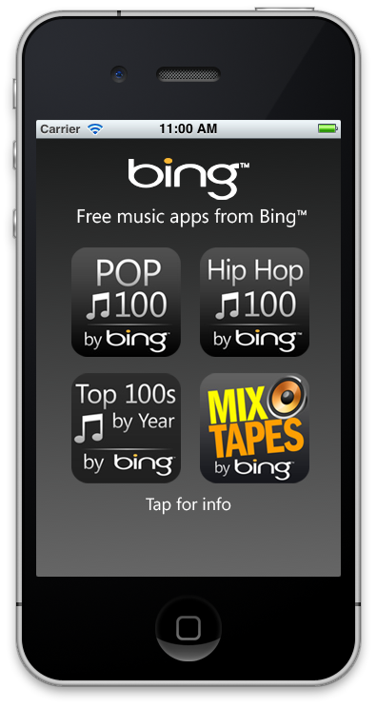

# Customize MASTAdView

## Customize view appearance.

1. By default in MASTAdView, animation is disabled.

To enable default animation set isAdChangeAnimated  property to YES.

1. By default in MASTAdView disable internalOpenMode.

To open the internal browser set internalOpenMode property to YES.

1. Also you can set defaultImage, autoCollapse and showPreviousAdOnError properties that determine what you want to when the error of ad update. Note, MASTAdView is always visible by default.



3. Set contentAlignment property to enable auto alignment content in center vertically and horizontally.

**Important**: Richmedia ad does not support this property.

4. Also you can apply default UIView customization such as animation, background color, support different orientations and so on.

## Customize content.

For the content filtration of the current user’s location, it’s possible to set the parameters of latitude, longitude or to use the Location manager, that is embedded in SDK, and it will determine the user’s position just once during the app’s start.

The usage of the embedded Location manager, gives an opportunity to add GEO option support into the ORMMA creative.

If the embedded location manager is used, the user will get the popup with the permission request.

For the switching on the of the embedded Location Manager it’s necessary: Switch off the build-in location manager. Go to the file 'MASTAdView.h’ and change its directive there «#undef INCLUDE_LOCATION_MANAGER” into “#define INCLUDE_LOCATION_MANAGER”.

You may filter content by set keywords, city, carrier, metro, etc. See API for details.

# Customize Interstitial ad

## Customize view appearance.

1. By default, there is a white close button of the interstitial ad. You can customize this button yourself. You can set the place and the icon size, also you can add the image on it. If you set UIButton then you need implement close logic too. If you want simply enable a default close button than set hidden property to NO.

2. To enable auto close interstitial timer - set time interval autoCloseInterstitial property, in seconds.

3. You can delay close button that is displayed by setting showCloseButtonTime property up.

## Customize content.

See the customize section of interstitial ad integration.

# Customize Ad Updates

SDK updates content by following events:

1. update Timer used (by default is 120 sec). This is the interval between finishing of the previous download and starting a new one.
2. by “update” method. Useful to preload content or change content on UI Rotate.
3. Control creation. Ad try to preload content by 0.1 sec after constructor finished. Note, it is important to have initialization done before it, so use required setters exact after constructor.

Note:

* Update Timer stopped:
  + if application is in background
  + MASTAdView is attached to hidden form
  + ORMMA ad is expanded

Once form becomes active again or application goes to foreground or ORMMA closed timer restarted.

* manual updates don’t not restart updatetimer.
* If several update events received at the same time, SDK creates the queue for the update of requests or send them one by one.

Troubleshooting

## Duplicate symbol compile error

If you get compile error like this:

/Users/william/Library/Developer/Xcode/DerivedData/theScoreMobile-testApp/Build/Products/Debug-iphoneos/libAdMobileSDK.a(SBJSON.o)"

It means that your project and SDK contain files with same name. In most cases this error appears due to the duplication of some framework. In this case – SBJSON.

To solve this problem you need to remove .m files for all files than cause this error. In this case – keep SBJSON.h and remove SBJSON.m and so on…

## Ads are not displayed the way you want.

1. Implement SDK error handling interface, to get know if you have any connection errors
2. Set the property logMode to AdLogModeAll to get all information about ad in console window.
3. Check if server has a content for you (an empty zone, an error zone and so on).
4. Check the banner displaying from the log history.
5. The reason of the wrong displaying may be the incorrect banner, you can check it just switching on the testMode mode. Working in this mode, the server will send the simple banners, which should be displayed all the time.

# MASTAdView Class Reference

|  |  |
| --- | --- |
| **Inherits from** | UIView |
| **Declared in** | MASTAdView.h |

## Overview

You use the MASTAdView class to embed advertisement content in your application. To do so, you simply create the MASTAdView object and add it to a UIView. An instance ofMASTAdView(or simply, an ad) is a mean for displaying advertisement information from ad publisher site. To choose ad publisher site, set parameters in the ad initialization methodinitWithFrame:site:zone: or use the properties site and zone. Use the adServerUrl property to choose alternative ad publisher server.

The Ad handles the rendering of any content in its area: Text ads, Images, Richmedia. Ad also handles any interactions with that content. So you can link from the banner to ad publishersite. Use the internalOpenMode property to set open mode for ad publisher site. To control all interactions, implement MASTAdViewDelegate protocol.

Ad always tries to load the content after creation. The time interval between load requests is managed using the property updateTimeInterval. Also you can update ad content immediately using the update method. Use the isLoading property to find out if the ad is in the process of loading or not, or implement callback. To configure ad visual appearance use the propertiesdefaultImage, autoCollapse, showPreviousAdOnError, textColor or contentAlignment. To manage the ad animation, use the property isAdChangeAnimated.

Advanced ad customization is supported. So you can filter the ad content using the premium property. Use the properties minSize and maxSize to configure ad content size in server response. Also you can set the search parameters or any other parameters using the properties keywords and additionalParameters accordingly.

To debug ad behavior use the properties testMode and logMode.

Set the delegate property to an object conforming to the MASTAdViewDelegate protocol if you want to listen the processing of ad content.

For the filtration of the content, SDK determines User-Agent automatically.if you wish to filter the content as an additional option, watch the section Filtering the MASTAdView Content.

## Tasks

### Initializing an MASTAdView Object

* – initWithFrame:site:zone:

### Configuring the MASTAdView

* site *property*
* zone *property*
* contentSize *property*
* defaultImage *property*
* autoCollapse *property*
* showPreviousAdOnError *property*
* closeButton *property*
* showCloseButtonTime *property*
* autocloseInterstitialTime *property*
* isAdChangeAnimated *property*
* updateTimeInterval *property*
* adServerUrl *property*
* adCallTimeout *property*
* contentAlignment *property*
* minSize *property*
* maxSize *property*
* track *property*
* internalOpenMode *property*
* textColor *property*

### Loading the MASTAdView Content

* isLoading *property*
* – update
* – stopEverythingAndNotfiyDelegateOnCleanup

### Filtering the MASTAdView Content

* premium *property*
* type *property*
* keywords *property*
* additionalParameters *property*
* country *property*
* region *property*
* city *property*
* area *property*
* metro *property*
* latitude *property*
* longitude *property*
* zip *property*
* carrier *property*

### Install Notification

* advertiserId *property*
* groupCode *property*

### Debug the MASTAdView

* testMode *property*
* logMode *property*

### Setting the Delegate

* delegate *property*

## Properties

### adCallTimeout

Maximum server response time.

@property (assign) NSInteger adCallTimeout

#### Discussion

Maximum server response time.

Specify timeout of ad call. This tells the ad server the maximum time you are willing to wait for an ad response.

The default value is 1000ms (milleseconds).

The max value is 3000ms (milleseconds).

#### Declared In

MASTAdView.h

### adServerUrl

Publisher server url.

@property (retain) NSString *adServerUrl

#### Discussion

Publisher server url.

The default value is <http://ads.AdMobile.mobi/ad> .

#### Declared In

MASTAdView.h

### additionalParameters

Custom request parameters.

@property (retain) NSDictionary *additionalParameters

#### Discussion

Custom request parameters.

Use this property to add custom request parameters.

The default value is nil.

**Note:** All keys and objects is need to be kind of NSString Class. For example:

[NSDictionary dictionaryWithObject:@"value" forKey:@"key"]

#### Declared In

MASTAdView.h

### advertiserId

Id of the advertiser for install notification.

@property (assign) NSInteger advertiserId

#### Discussion

Id of the advertiser for install notification.

**Note:** Install notification enabled only if advertiserId and groupCode are specified.

#### Declared In

MASTAdView.h

### area

Area code of a user. For US only.

@property (retain) NSString *area

#### Discussion

Area code of a user. For US only.

The default value is nil.

#### Declared In

MASTAdView.h

### autoCollapse

A Boolean value that determines whether to hide ad in case error depending on other properties

@property BOOL autoCollapse

#### Discussion

A Boolean value that determines whether to hide ad in case error depending on other properties

Use this property to hide ad in case of error.

The default value is YES.

#### Declared In

MASTAdView.h

### autocloseInterstitialTime

Auto close interstitial time interval, in seconds.

@property NSTimeInterval autocloseInterstitialTime

#### Discussion

Auto close interstitial time interval, in seconds.

Setting to -1 will disable auto closing interstitial.

The default value is -1.

#### Declared In

MASTAdView.h

### carrier

User carrier.

@property (retain) NSString *carrier

#### Discussion

User carrier.

The default value is nil.

#### Declared In

MASTAdView.h

### city

City of the device user (with state). For US only.

@property (retain) NSString *city

#### Discussion

City of the device user (with state). For US only.

The default value is nil.

#### Declared In

MASTAdView.h

### closeButton

Close button.

@property (retain) UIButton *closeButton

#### Discussion

Close button.

Set this value to customize close button appearance and behaviour.

By default closed button set by SDK with hidden property YES.

**Note:** If you set UIButton then you need implement close logic too.

**Note:** If you want simply enable default close button set hidden property to NO.

#### Declared In

MASTAdView.h

### contentAlignment

A Boolean value that determines whether content alignment is centered vertically and horizontally.

@property BOOL contentAlignment

#### Discussion

A Boolean value that determines whether content alignment is centered vertically and horizontally.

Set the value of this property to YES, that enables auto wrapping server response content in HTML table with alignment.

The default value is NO.

**Important:** You need to disable animation if you specify your own.

#### Declared In

MASTAdView.h

### contentSize

Size of the ad content must be shown.

@property (readonly) CGSize contentSize

#### Discussion

Size of the ad content must be shown.

Use this property to get the actual size of the ad content. Property value updated after ad content downloaded.

**Note:** If size unavailable property returns CGRectZero.

#### Declared In

MASTAdView.h

### country

The country of visitor. It overrides country detected by IP. It is ISO 3166 to be used for specifying country code.

@property (retain) NSString *country

#### Discussion

The country of visitor. It overrides country detected by IP. It is ISO 3166 to be used for specifying country code.

The default value is nil.

#### Declared In

MASTAdView.h

### defaultImage

Image for unloaded ad state.

@property (retain) UIImage *defaultImage

#### Discussion

Image for unloaded ad state.

Set the value of this property, that determines the ad default image for the unloaded state. In this state the content of the ad is invisible and ad default image is displayed. Without connection to the internet default image will be displayed.

The default value is nil.

#### Declared In

MASTAdView.h

### delegate

The receiver’s delegate.

@property (assign) id<MASTAdViewDelegate> delegate

#### Discussion

The receiver’s delegate.

The MASTAdView is sent messages when content is processing. The delegate must adopt the MASTAdViewDelegate protocol. The delegate is not retained.

**Important:** Before releasing an instance of MASTAdView for which you have set a delegate, you must first set its delegate property to nil. This can be done, for example, in your dealloc method.

#### See Also

* MASTAdViewDelegate Protocol Reference for the optional methods this @property delegate may implement.

#### Declared In

MASTAdView.h

### groupCode

Group code for install notification.

@property (retain) NSString *groupCode

#### Discussion

Group code for install notification.

**Note:** Install notification enabled only if advertiserId and groupCode are specified.

#### Declared In

MASTAdView.h

### internalOpenMode

A Boolean value that determines whether an ad internal browser is enabled.

@property BOOL internalOpenMode

#### Discussion

A Boolean value that determines whether an ad internal browser is enabled.

Set the value of this property to NO disables internal browser, so after linking from the banner the ad publisher site will be opened in Safari.

To handle opening/closing internal browser use MASTAdView delegate or viewWillAppear/viewWillDisappear methods of UIViewController.

The default value is NO.

#### Declared In

MASTAdView.h

### isAdChangeAnimated

A Boolean value that determines whether ad animate mode is enabled.

@property BOOL isAdChangeAnimated

#### Discussion

A Boolean value that determines whether ad animate mode is enabled.

Set the value of this property to YES, enable ad animate mode and set it to NO disables this mode.

The default value is NO.

#### Declared In

MASTAdView.h

### isLoading

A Boolean value that determines whether ad is in the process of loading.

@property (readonly) BOOL isLoading

#### Discussion

A Boolean value that determines whether ad is in the process of loading.

#### Declared In

MASTAdView.h

### keywords

Keywords for search ads.

@property (retain) NSString *keywords

#### Discussion

Keywords for search ads.

Use this property to search ads. The values are delimited by commas.

The default value is nil.

#### Declared In

MASTAdView.h

### latitude

User location latitude value.

@property (retain) NSString *latitude

#### Discussion

User location latitude value.

Use this property to set latitude. The value @“” will stop coordinates of auto-detection and coordinates will not be sent to the server. Any other values also will stop the coordinates of auto-detection but coordinates will be sent to the server.

The default value is auto-detected by locationManager and sent to server.

#### Declared In

MASTAdView.h

### logMode

AdLogMode value that determines log level.

@property AdLogMode logMode

#### Discussion

AdLogMode value that determines log level.

typedef enum { AdLogModeNone = 0, AdLogModeErrorsOnly = 1, AdLogModeAll = 2 } AdLogMode;

Setting the value of this property to AdLogModeNone disables ads logging. AdLogModeErrorsOnly – enables logging errors only. AdLogModeAll – enables logging errors and info.

The default value is AdLogModeErrorsOnly.

#### Declared In

MASTAdView.h

### longitude

User location longitude value.

@property (retain) NSString *longitude

#### Discussion

User location longitude value.

Use this property to set longitude. The value @“” will stop the coordinates of the auto-detection and these coordinates will not be sent to the server. Any other values also will stop the coordinates of auto-detection but these coordinates will be sent to server.

The default value is auto-detected by locationManager and sent to server.

#### Declared In

MASTAdView.h

### maxSize

Maximal size of the ad content can be shown.

@property CGSize maxSize

#### Discussion

Maximal size of the ad content can be shown.

Use this property to set the maximal size of the ad content and server response will be close to this size.

#### Declared In

MASTAdView.h

### metro

Metro code of a user. For US only.

@property (retain) NSString *metro

#### Discussion

Metro code of a user. For US only.

The default value is nil.

#### Declared In

MASTAdView.h

### minSize

Minimal size of the ad content can be shown.

@property CGSize minSize

#### Discussion

Minimal size of the ad content can be shown.

Use this property to set the minimal size of the ad content and server response will be close to this size.

#### Declared In

MASTAdView.h

### premium

Ad premium filter.

@property AdPremium premium

#### Discussion

Ad premium filter.

typedef enum { AdPremiumNonPremium = 0, AdPremiumPremium, AdPremiumBoth } AdPremium;

Use this property to filter the content of ad by premium status.

The default value is AdPremiumNonPremium.

#### Declared In

MASTAdView.h

### region

Region of visitor. ISO 3166-2 is used for United States and Canada and FIBS 10-4 is used for other countries.

@property (retain) NSString *region

#### Discussion

Region of visitor. ISO 3166-2 is used for United States and Canada and FIBS 10-4 is used for other countries.

The default value is nil.

#### Declared In

MASTAdView.h

### showCloseButtonTime

Show close button delay time interval, in seconds.

@property NSTimeInterval showCloseButtonTime

#### Discussion

Show close button delay time interval, in seconds.

Setting to -1 will show close button immediately.

The default value is -1.

#### Declared In

MASTAdView.h

### showPreviousAdOnError

A Boolean value that determines whether to show previous ad in case of error depending on other properties

@property BOOL showPreviousAdOnError

#### Discussion

A Boolean value that determines whether to show previous ad in case of error depending on other properties

Use this property to show previous ad in case of error.

The default value is YES.

#### Declared In

MASTAdView.h

### site

Id of the publisher site.

@property (assign) NSInteger site

#### Discussion

Id of the publisher site.

Value setting of this property determines the id of the publisher site, so switching between publisher sites is possible. The default value is copied from parameter site of ad initialization method.

#### Declared In

MASTAdView.h

### testMode

A Boolean value that determines whether ads test mode is enabled. Setting the value of this property to YES enables ads test mode and setting it to NO disables ads test mode.

@property BOOL testMode

#### Discussion

A Boolean value that determines whether ads test mode is enabled. Setting the value of this property to YES enables ads test mode and setting it to NO disables ads test mode.

The default value is NO.

#### Declared In

MASTAdView.h

### textColor

Color of ad text links.

@property (retain) UIColor *textColor

#### Discussion

Color of ad text links.

The default value is nil.

**Note:** Alpha value ignored.

#### Declared In

MASTAdView.h

### track

A Boolean value that determines whether ad track is enabled.

@property BOOL track

#### Discussion

A Boolean value that determines whether ad track is enabled.

If set to YES, the ad server will send a client side impression tracking pixel with each ad, regardless of if the campaign has this property set or not. Impressions will not be counting if this pixel does not render on the device.

The default value is NO.

#### Declared In

MASTAdView.h

### type

Ad type filter.

@property AdType type

#### Discussion

Ad type filter.

typedef enum { AdTypeTextOnly = 1, AdTypeImagesOnly = 2, AdTypeImagesAndText = 3, AdTypeRichmedia = 4, AdTypeRichmediaAndText = 5, AdTypeRichmediaAndImages = 6, AdTypeAll = 7 } AdType;

Use this property to filter the content of ad by type.

#### Declared In

MASTAdView.h

### updateTimeInterval

Update time interval, in seconds.

@property NSTimeInterval updateTimeInterval

#### Discussion

Update time interval, in seconds.

The value of this property determines time interval between ads updating. This interval is counted after finish loading content, so the ad will start updating only after loading is finished and time interval is passed.

Setting value in range from 0 to 5 will apply 5 seconds to prevent too fast ad updates.

Setting to 0 will stop updates. All positive values enable updates.

The default value is 120.

#### Declared In

MASTAdView.h

### zip

Zip/Postal code of user (note: parameter is all caps). For US only.

@property (retain) NSString *zip

#### Discussion

Zip/Postal code of user (note: parameter is all caps). For US only.

The default value is nil.

#### Declared In

MASTAdView.h

### zone

Id of the publisher zone.

@property (assign) NSInteger zone

#### Discussion

Id of the publisher zone.

Set the value of this property determines the id of the publisher zone, so switching between publisher zones is possible. The default value is copied from parameter zone of ad initialization method.

#### Declared In

MASTAdView.h

## Instance Methods

### initWithFrame:site:zone:

Initializes and returns an MASTAdView object having the given frame, site and zone.

- (id)initWithFrame:(CGRect)frame site:(NSInteger)site zone:(NSInteger)zone

#### Parameters

frame

A rectangle specifies the initial location and size of the ad view in its superview’s coordinates.

site

A value that specifies the id of ad publisher site.

zone

A value that specifies the id of ad publisher zone.

#### Return Value

Returns an initialized MASTAdView object or nil if the object could not be successfully initialized.

#### Discussion

Initializes and returns an MASTAdView object having the given frame, site and zone.

#### Declared In

MASTAdView.h

stopEverythingAndNotfiyDelegateOnCleanup

Use this method, if you want to close the ad quickly and clear all resource.

- (void)stopEverythingAndNotfiyDelegateOnCleanup

#### Discussion

Use this method, if you want to close the ad quickly and clear all resource.

#### Declared In

MASTAdView.h

### update

Starts to update the ad content immediately.

- (void)update

#### Discussion

Starts to update the ad content immediately.

Call this method if you want update the ad content immediately (for example, after setting site and zone or changing adServerUrl). If ad is in the process of loading it will be interrupted.

#### Declared In

MASTAdView.h

# MASTAdViewDelegate Protocol Reference

|  |  |
| --- | --- |
| **Conforms to** | NSObject |
| **Declared in** | MASTAdDelegate.h |

## Overview

The MASTAdViewDelegate protocol defines methods that is the delegate of a MASTAdView object and can optionally be implemented to receive notifications from the ad.

## Tasks

* – willReceiveAd:
* – didReceiveAd:
* – didReceiveThirdPartyRequest:content:
* – didFailToReceiveAd:withError:
* – adWillStartFullScreen:
* – adDidEndFullScreen:
* – adShouldOpen:withUrl:
* – didClosedAd:usageTimeInterval:
* – ormmaProcess:event:parameters:

## Instance Methods

### adDidEndFullScreen:

Sent after an ad view is finished displaying internal browser.

- (void)adDidEndFullScreen:(id)sender

#### Parameters

sender

The ad view has finished displaying internal browser.

#### Discussion

Sent after an ad view finished displaying internal browser.

#### Declared In

MASTAdDelegate.h

### adShouldOpen:withUrl:

Sent before an ad view will start to open URL.

- (BOOL)adShouldOpen:(id)sender withUrl:(NSURL *)url

#### Parameters

sender

The ad view that is about to open URL.

url

The URL that should be opened in internal or external browser.

#### Return Value

Returns YES to allow SDK open browser otherwise returns NO.

#### Discussion

Sent before an ad view will start to open URL.

Implement this method with return NO value if you want to control opening ads by your self.

This method is optional. If you do not implement this method, the SDK accepts YES as return value.

#### Declared In

MASTAdDelegate.h

### adWillStartFullScreen:

Sent before an ad view will start to display internal browser.

- (void)adWillStartFullScreen:(id)sender

#### Parameters

sender

The ad view that is about to display internal browser.

#### Discussion

Sent before an ad view will start to display internal browser.

**Important:** This method is called after adShouldOpen:withUrl: returns YES or not implemented.

**Important:** This method is not called an opening ads in Safari (internalOpenMode set to NO). To handle this behavior it’s necessary to implement the UIApplicationDelegate protocol

#### Declared In

MASTAdDelegate.h

### didClosedAd:usageTimeInterval:

Sent after an ad view is closed and tracks the usage time of ad interstitial view.

- (void)didClosedAd:(id)sender usageTimeInterval:(NSTimeInterval)usageTimeInterval

#### Parameters

sender

The ad view was closed.

usageTimeInterval

The usage time interval of ad view.

#### Discussion

Sent after an ad view closed and tracks the usage time of ad interstitial view.

#### Declared In

MASTAdDelegate.h

### didFailToReceiveAd:withError:

Sent if an ad view failed to load ad content.

- (void)didFailToReceiveAd:(id)sender withError:(NSError *)error

#### Parameters

sender

The ad view that is failed during the loading of the ad content.

error

The error that occurred during loading.

#### Discussion

Sent if an ad view is failed for loading of the ad content.

The same method can be invoked if the server does not currently advertising.

#### Declared In

MASTAdDelegate.h

### didReceiveAd:

Sent after an ad view has finished loading ad content.

- (void)didReceiveAd:(id)sender

#### Parameters

sender

The ad view has finished loading.

#### Discussion

Sent after an ad view finished loading of the ad content.

#### Declared In

MASTAdDelegate.h

### didReceiveThirdPartyRequest:content:

Sent if SDK received client side third party campaign.

- (void)didReceiveThirdPartyRequest:(id)sender content:(NSDictionary *)content

#### Parameters

sender

The ad view that receives 3rd party ad content.

content

The dictionary of strings (key/values) for third party. You can start processing this content from @“type” key for determining ads type.

#### Discussion

Sent if SDK received client side third party campaign.

Generally, this method is called if the SDK can’t display the ads due to the reliance on a third party. For example: AdMob, Rhythm or SmartAdServer

**Important:** The SDK will never display the ads which trigger this method! They are used to call the third party SDKs in your app.

#### Declared In

MASTAdDelegate.h

### ormmaProcess:event:parameters:

Sent after an ad process ORMMA command.

- (void)ormmaProcess:(id)sender event:(NSString *)event parameters:(NSDictionary *)parameters

#### Parameters

sender

The ad view that is about to process ORMMA event.

event

The string with name of the event.

parameters

The Dictionary with parameters from event.

#### Discussion

Sent after an ad process ORMMA command.

**Important:** Implement this method only if you want to add the additional logic for event. By default SDK already implemented all methods and your code could conflict with SDK

#### Declared In

MASTAdDelegate.h

### willReceiveAd:

Sent before an ad view will begin loading the ad content.

- (void)willReceiveAd:(id)sender

#### Parameters

sender

The ad view that is about to load ad content.

#### Discussion

Sent before the an ad view will begin loading ad content.